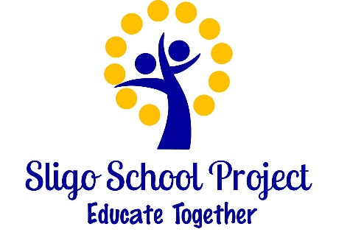
ANNUAL ADMISSION NOTICE
in respect of admissions to the 2026/2027 school year

Admission Policy and Application Form
A copy of the school’s Admission Policy and the Application Form for Admission for the year 2026/2027 is available as follows: –
To download at: www.sligoschoolproject.ie
On request: By emailing sligosp@gmx.com or writing to: Sligo School Project
Abbey Quarter, Sligo, F91XF51, Republic of Ireland.

Application and Decision Dates for admission to 2026/2027
The school will commence accepting applications for admission on | 27th of February 2026
The school shall cease accepting applications for admission on | 20th of  March 2026
The date by which applicants will be notified of the decision on their application is | 27th of  March 2026
The period within which applicants must confirm acceptance of an offer of admission ends | 17th of  April 2026

Note: applications made after the 20th March 2026 will be processed as late applications, the school will consider and issue decisions on late applications in accordance with the school’s admission policy.

Failure of an applicant to accept an offer by the 17th April 2026 may result in the offer being withdrawn.

Number of places being made available in 2026/2027
The number of places being made available in junior infants | 6

The BOM has deemed 6 as the number of spaces available in junior infants. The BOM reserves the right to change this number as necessary.

